**2020 NFL Draft Fan Sentiment: An Exploratory Analysis**

MGT 6203 Group Project - Fall 2023

[Team 79 GitHub](Team%2079%20GitHub)

**TEAM 79:**

Hugh Hoagland

Raju Ahmed

Pablo Francisco Ramos Soszna

Alexander Martin Stetzer

Nicholas Weist

Table of Contents

**Background3**

**Objective3**

**Methodology3**

Comment Analysis3

Performance Analysis6

**Approach9**

**Conclusion9**

**Background**

In the ever-evolving landscape of professional sports in the United States, the National Football League (NFL) towers above the rest, both in terms of revenue generation and the unwavering dedication of its passionate fanbase. As of 2022, the NFL's annual revenue surpassed a staggering $11.9 billion (Forbes, 2023), solidifying its status as an economic powerhouse. The influence of the NFL extends far beyond the realm of sports, with entire industries, such as fantasy football, flourishing in its wake. At the heart of this lies the NFL draft, a pivotal event that serves to infuse new talent into the league and offers the opportunity for the keen manager to infuse their team with fresh talent that may be overlooked by others.

The NFL draft is a process characterized by notable outliers, showcasing remarkable success stories and stark failures. Examples like Tom Brady, who was selected as the 199th overall pick and went on to become the player with the most Super Bowl championship wins, and JaMarcus Russell, who was chosen as the first overall pick but quickly descended into the ranks of notable busts, highlight the complexity and uncertainty that surrounds this critical juncture in the NFL's operation. The NFL draft, as a pipeline for emerging football talent, represents a microcosm of the challenges and opportunities intrinsic to the league's success.

The Covid-19 pandemic introduced a unique twist to the 2020 NFL draft process by forcing the event to be fully remote. In lieu of in-person attendance, fans were encouraged to post to NFL-related subreddits and express their opinions on their respective teams' draft picks. These comments and reactions, spanning the entirety of the draft, were assigned sentiment scores, ranging from -1 (extremely negative) to 1 (extremely positive). This shift towards social media allowed the collection of data produced a natural experiment and provided valuable data to study the collective, crowd-sourced evaluation of draft picks similar to statistician Francis Galton’s observation of the "wisdom of crowds" (Vox Populi, 1907).

Through a comprehensive analysis of fan sentiment in Reddit comments during the NFL draft, this research aims to determine whether such sentiment can provide measurable benefits to NFL team managers in improving draft selections and subsequently impacting player success in the league.

**Objective**

Our research comprises three key components: accurate ingestion of Reddit comments to ensure data reliability, the development of performance metrics for objective player assessment, comparative analysis of fan sentiment, draft positions, and player performance over three NFL seasons with the ultimate goal of empowering decision-makers with actionable insights. By exploring the relationship between fan sentiment and player success, we aim to test the hypothesis that fan sentiment, as extracted from Reddit comments, can quantifiably benefit managers in improving draft selections.

**Overview of Data**

**Data Sources**

To test the hypothesis, our team relied on two categories of data sources. The first pertains to determining sentiment associated with draft decisions. To achieve this, we combined multiple datasets from Kaggle that provided the components of our draft analysis, timestamped draft picks and similarly timestamped Reddit comments and their sentiment scores. The second category focuses on player performance metrics. In our quest to assess player success, we examined various sources, but ultimately made the decision to construct a proprietary scoring system, with its basis being derived from Pro Football Focus' (PFF) popular "player grade" system.

**Exploratory Data Analysis**

1. **Comment analysis**

To achieve our project's goal of comprehending fan sentiment during the 2020 NFL draft and its potential impact on NFL teams, we cleaned and aligned Kaggle datasets. The first step taken was to combine the round data frames into a single data frame. As shown in Figure 1, we noticed there were higher number of reddit comments during the earlier round of the draft.

|  |  |
| --- | --- |
| (a) | (b) |

Figure 1: (a) Reddit comment bucketed by time stamp & (b) comment with images bucketed by timestamp

Based on our initial analysis of positive and negative sentiment for time stamps containing videos and images, as shown in Figure 1(b), we found that those rows show no clear trend, represent a small fraction of the data, and are not accurately captured by the sentiment scoring system (Vader). Therefore, they were omitted from the ultimate dataset.

To associate comments with draft pick, using a look up table based on the original picks data frame, a series of operations calculate the previous timestamp in the picks data frame and associate that pick’s timestamp, round, pick number, player name and team name with the comment’s timestamp. This dataset now contains a valid timestamp, round number, pick number, player name and selecting team value for each individual comment with which to predict performance.

2

Figure 3 shows the summary of associated picks and their respective number or rows indicating that 75% of the picks will have at least 440 rows of data. Since the number of rows associated with each pick is quite high, an analysis of player name frequency was necessary.

**Player Name Analysis**

The project aims to determine if fan sentiment towards drafted players correlates with their on-field performance. While Reddit post sentiment scores reflect comment sentiment, many comments are irrelevant to players or picks. To address this, we examined the number of comments mentioning a player's name. From the summary, we found that median player has about 9 comments with their name, while the top ten players have several hundred (Figure 4). This discrepancy suggests a potential variable for identifying draft superstars

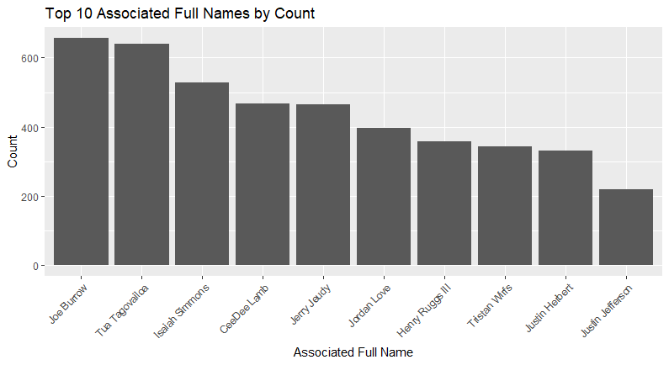

Figure 3: Top 10 payer full names by count

1. **Offensive Words and Fan Sentiment**

To explore correlation between the reddit comment and sentiment score, we have analyzed the contents of the text against a list of top 50 offensive/slang language words against the text. Finding such a library was challenging due to ethical concerns surrounding offensive words.. The goal of this analysis was to check whether these words can predict a bad sentiment score. These top slang/offensive words used for the library were collected from various dictionaries, social media platforms, news articles, and rap and hip-hop songs, the top 20 of which are shown with associated sentiments in table 1 below.

|  |  |
| --- | --- |
|  |  |
| Table 1: Distribution of sentiment scores of top 20 offensive words | Figure 4: Top 10 offensive words and associated mean sentiment scores with standard deviation |

Analyzing the offensive words and sentiment score we discovered a few interesting facts, traditional offensive languages are generally associated with poor sentiment scores, as shown in Figure 3. The count of the offensive words with low median sentiment can therefore be an interesting variable to predict the draft pick.

**iv.Team Sentiment**

Beyond the player’s draft positions and social media vernacular, we had a final question of the draft data about how to compare the effect of each team’s fans on the comment collection process as most comments were generated by fans, and fans are generally loyal to a team as opposed to the entirety of the NFL.

By and large, the team’s sentiments had similar shapes clustered around zero but with a slight positive skew (Figure 7). This is in line with the general distribution (Figure 3) and confirms that no team is responsible for a disproportionate number of positive or negative comments.

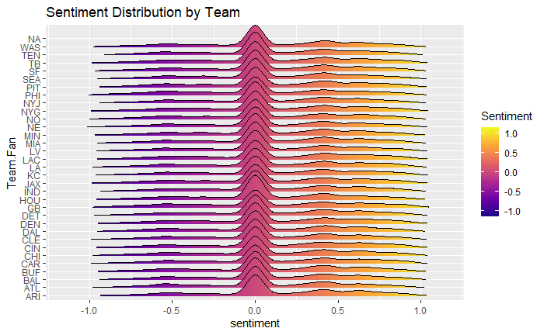

Figure 5: Sentiment scores by team Figure 6: Proportion of comments to sentiment by team

One avenue we intend to explore is whether average sentiment and proportion of count both have predictive power independent of each other.

1. **Player Performance Data Methodology**

Table 2: Wins Above Replacement by Position

Player evaluation is a complex area of NFL analysis. We initially considered using fantasy football data but discarded it due to inconsistent scoring methodologies. We then turned to Pro Football Reference (PFR) and extracted data for various positions. However, data limitations for positions like punters and offensive linemen necessitated their exclusion from the initial analysis.

Seeking a more established metric, we explored Wins Above Replacement (WAR), analogous to baseball's WAR. However, a standardized WAR metric for football is unavailable. We instead utilized Eager and Chahrouri's "PFF WAR: Modeling Player Value in American Football" to adjust fantasy PPG based on positional value and variance as shown in Table 2.

This approach, while promising, presented challenges in balancing factors that contributed to the scaling factor. Our findings revealed model limitations and inconsistencies, exacerbated by data absence for certain positions. Consequently, we made the critical decision to reassess our methodology.

**Methodology: Utilizing PFF Player Grades as the Baseline Metric**

Our current methodology for assessing player performance centers on PFF's "player grade" as the foundational metric. We chose this approach due to its comprehensive evaluation of individual contributions on the football field. PFF's grading system offers a few key benefits that helped us select it as our baseline.

First, contribution to production, PFF's grading system scrutinizes every player on every play, emphasizing their "contribution to production" rather than relying on inherent traits or measurable attributes. Second, grading scale, PFF employs a grading scale ranging from -2 to +2 in 0.5 increments, tailored for each position. This approach ensures an impartial assessment, considering the unique demands of each role on the field. Third, the methodology involves over 600 analysts, comprising former players, coaches, and diverse backgrounds, contribute to the grading process. The final grades are determined by the top analysts within the organization. Finally, 0-100 Scale, PFF's grades are further converted to a 0-100 scale at both the game and season levels, facilitating straightforward player comparisons. PFF's grading system, which does not inherently consider positional importance, serves as an ideal standardized starting point for our analysis.

**Data Collection and Cleaning Methodology**

To construct a comprehensive dataset, we gathered regular season player performance data from PFF (2015-2022) and draft summary information from Pro Football Reference (2015-2020). We standardized team names and player positions for data uniformity. This unified dataset lays the foundation for our analysis of player performance, draft outcomes, and their interconnected dynamics.

**Early Assessments of Draft Performance**

We have created a slightly modified metric "Raw Value Provided (RVP)" to assess the total value of a player within a specific season. The calculation is:



To thoroughly assess the 2020 NFL Draft player performance, we established a baseline by analyzing the 2015-2019 drafts. Considering the limited data for the 2020 class, we focused on the initial three seasons of each pick. Though this approach overlooks position-specific nuances like career longevity and peak performance, it serves as a necessary control for baseline establishment. We calculated the total Relative Value Points (RVP) over three seasons for each 2015-2019 draft member and determined an aggregated average 3-year RVP for each position-round combination (Figure 9).

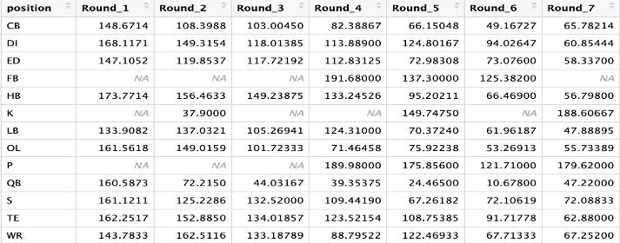

Figure 7: Average 3-year Raw Value Provided

Using these averages, we identified the variance between expected and actual three-year RVP for the 2020 draft class. Notably, top picks exhibited a blend of generational talents in early rounds and value picks in later rounds.

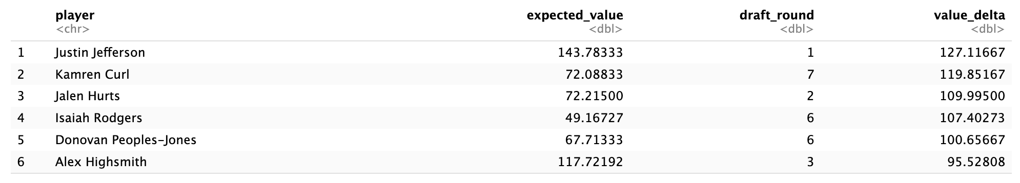

Figure 8: Expected Player Value for Top Draft Picks

By aggregating the total difference in expected value for teams, our methodology revealed that the Titans had the least favorable 2020 draft, with a total difference of -306.1, while the Bengals had the most successful draft, boasting a difference of 285.4. This aligns with assessments from prominent NFL draft analysts and platforms.

**Overview of Modeling**

In our initial conception of this project, our primary objective was to evaluate the efficacy of variables derived from Reddit comments in predicting a player's performance, as quantified by the "raw_value_provided" variable, to offer a different and independent approach to the traditional draft selection process. Unfortunately, the majority of these variables exhibited limited predictive capability, with only a select few demonstrating any significance, particularly those associated with mentions of the player within the Reddit discussions. The collective predictive power of the variables was also low, having an adjusted R-squared of 0.1775, indicating a challenge in forecasting player performance based on the extracted features (Figure 9). In light of this, we found it necessary to reassess our initial approach, which involved proposing a distinct draft selection process independent of General Managers. The realization of the overall low predictability prompted a reconsideration of our initial framework.

Figure 9: Regression of Reddit Comment Variables

This outcome is not unanticipated as we considered it a strong possibility from the outset that General Managers likely possess superior insights compared to the average NFL viewer or Reddit commenter, as that is likely why they were hired in the first place. As seen in figure 10 below, with the player's expected_value (a value capturing a combination of a player’s draft round and pick) serving as a surrogate for a General Manager's assessment of a player's potential, explains a substantial portion of the variance in player performance. This underscores the significance of incorporating General Manager’s perspectives into the overall evaluation framework and necessitated an approach that seeks to further a General Manager’s insight as opposed to replacing it.

Figure 10: General Manager Predictive Power

In this pursuit of providing a competitive advantage in the drafting process, we expanded upon our baseline regression analysis by exploring various additive modeling approaches that would improve upon the Coach’s ability to predict performance. Specifically, we investigated the efficacy of a weighted average regression, two-stage least squares model, and two-level random forest model to identify potential enhancements.

**Weighted Average Regression**

For the Weighted Average Regression, we tried a weighted average regression model, incorporating sentiment-related predictors. For this we used two regression models, the baseline regression model of expected_value to value_provided and one for predicting value_delta, a proxy for player performance that scales the data per position.

Predictions were generated for both the baseline and additional regression models. Multiple weights were then systematically varied to optimize R-squared values, providing insights into the most effective combination of the two types of models. Despite this iteration and the incorporation of sentiment-related predictors, the weighted average regression models failed to yield significant improvements in predicting sum_raw_value_provided. Any combination with the baseline model weighted to less than 1 had a worse adjusted R-squared value. The R-squared values obtained through optimization remained relatively consistent, indicating that sentiment analysis from Reddit comments, when combined with our additional model, did not enhance the overall predictive power of the models.

**Two-Stage Least Squares**

Our next tactic was to look at the residuals of the base regression by using a two-stage least squares model. For this, we started with the original regression analysis on the raw_player_value. Subsequently, we performed a secondary regression on the residuals, utilizing only the features deemed significant from our prior analyses: 'Direct_mentions,' 'offensive_word_count,' and 'Indirect_mentions'. We then integrated these results with the baseline regression and explored various combinations to discern any potential improvements in the predictive ability of the model (Fig. 11). Unfortunately, none of the combinations yielded significant enhancements.

Figure 11: Adjusted R-Squares of the two-stage least squares model at different scaling factors

**Two-Level Random Forest Model**

The final model we attempted was the Random Forest model, incorporating key predictors such as position, draft round, and expected player value. Tuned for optimal performance, this model serves as a baseline, drawing from historical precedents and collective wisdom surrounding drafting positions and rounds. However, the pursuit of constructing a more refined predictive model prompted the exploration of a second layer, where the predictions from the initial Random Forest model were employed as predictors.

After tuning the first layer, we found the optimal number of predictors at each branch to be mtry=2. This layer aimed to encapsulate the intrinsic variability in player performance, guided by historical drafting wisdom. In essence, this layer looked to provide a similar baseline as our regression model, allowing us to account for the knowledge that a General Manager brings, before attempting to add additional insight.

Layer two comprised various model iterations, combining both Random Forest and linear regression approaches, with the predictions from layer one as key predictors. Three standout models emerged:

**Model 1:** A second Random Forest model incorporating predictors like layer one predictions, average sentiment from indirect mentions, and mean sentiment.

**Model 2:** A linear regression model with a minimalist approach, solely relying on layer one predictions. Surprisingly, this "control" model, devoid of sentiment data, exhibited superior performance on the test data.

**Model 3:** Another linear regression model with predictors including layer one predictions, direct mentions, average sentiment from indirect mentions, and mean sentiment. While resembling Model 2, the increased complexity did not yield additional predictive power.

While Model 3 performed as well as Model 2 (fig 12), we would expect it to have better predictability if the fan comments or sentiments were to offer anything to a drafting General Manager.

Figure 12: Root Mean Squared Errors for the three Random Forest Models

**Conclusion**

In the dynamic landscape of the NFL, where teams are looking for any potential competitive advantage, no matter how far afield it may seem, our research sought to investigate the potential of leveraging Reddit comments to assist General Managers in making informed decisions during the player drafting process. The NFL draft, a cornerstone event, encapsulates the intricate balance of identifying emerging talents and managing uncertainties, symbolized by the league's success stories and cautionary tales.

Our exploration, spurred by the unique circumstances of the 2020 NFL draft conducted entirely remotely due to the COVID-19 pandemic, tapped into the wealth of fan sentiment expressed through Reddit comments. This endeavor sought to align with the concept of the "wisdom of crowds," wherein collective insights may transcend individual perspectives.

Initially, our aspiration was to construct a predictive model utilizing variables derived from Reddit comments, offering an alternative paradigm to the traditional draft selection process. However, our analyses revealed that reality is likely more subtle, and the current process of selecting players has a wisdom of its own. The majority of variables exhibited limited predictive capacity, and any collective predictive power was modest, challenging the feasibility of solely relying on fan sentiment for forecasting player performance.

A pivotal realization was the acknowledgment that General Managers, possessing unique insights and expertise, are likely to have a more profound understanding of player potential compared to the average viewer or Reddit commenter. This recognition prompted a shift in our approach, emphasizing the integration of their perspectives rather than proposing an independent draft selection process.

Our regression analyses unveiled the substantial predictive power embedded in the General Managers assessment, represented by the player's expected value, which captures a combination of draft round and pick. This finding underscores the significance of conventional wisdom and necessitated a recalibration of our methodology to enhance rather than replace the current decision-making process.

In our pursuit of providing a drafting edge, we explored advanced modeling techniques such as two-stage least squares, weighted average regression, and a two-level random forest model. Despite these efforts, the enhancements in predictive ability were elusive, emphasizing the challenges inherent in predicting player performance solely based on Reddit comments.

In conclusion, while our initial goal of establishing an independent draft selection process guided by Reddit sentiment faced limitations, our research contributes valuable insights. While we did not find any predictive power from the natural experiment that occurred during the virtual 2020 draft, we did find that there is certainly room for improvement on the part of the General Managers. With an adjusted R-squared of 0.2348, the variance in player behavior is not well explained by their ability either.

In light of this we advocate that General Managers not stop looking for additional insights, whether they be from crowd sentiment or another source. It turns out that the draft selection process is difficult. The journey continues as we navigate the evolving intersection of technology, sports, and decision science, seeking innovative ways to empower decision-makers in the ever-evolving landscape of the NFL.

**Data Sources and Code repository**

https://github.gatech.edu/MGT-6203-Fall-2023-Canvas/Team-79

**Works Cited**

Galton, Francis. “Vox Populi.” *Nature News*, Nature Publishing Group, www.nature.com/articles/075450a0. Accessed 3 Nov. 2023.

Ozanian, Mike. “NFL National Revenue Was Almost $12 Billion in 2022.” *Forbes*, Forbes Magazine, 14 July 2023, www.forbes.com/sites/mikeozanian/2023/07/11/nfl-national-revenue-was-almost-12-billion-in-2022/.

Eager, Eric, and George Chahrouri. "PFF WAR: Modeling Player Value in American Football." MIT Sloan Sports Analytics Conference, n.d., www.sloansportsconference.com/research-papers/pff-war-modeling-player-value-in-american-football

Dean, Jeff, et al. “Grading the 2020 NFL Draft Class.” Sports Info Solutions, 23 May 2023, www.sportsinfosolutions.com/2023/05/09/grading-the-2020-nfl-draft-class/.

“NFL Draft: Which Teams Have Gotten the Best Value since 2012?” ESPN, ESPN Internet Ventures, 22 Apr. 2022, www.espn.com/nfl/story/_/id/33297949/nfl-draft-which-teams-gotten-best-value-2012-rank-all-32.

**Team Background**

* Hugh Hoagland (hhoagland6) has a BS in Statistics and Business from the University of Tennessee.
* Raju Ahmed (rahmed73) has BS & MS in Applied Physics, PhD in Materials Science and Engineering from Texas State University.
* Pablo Francisco Ramos Soszna (psoszna3) completed his Undergrad in Business Technology from the University of Miami.
* Alexander Martin Stetzer (astetzer3) completed his Undergrad in Physics from UW-La Crosse and Aerospace Engineering UM-Twin Cities.
* Nicholas Weist (nweist3) completed his Undergrad with a dual major in Math and Econ from the University of Connecticut.